**View of the main page of the website.**

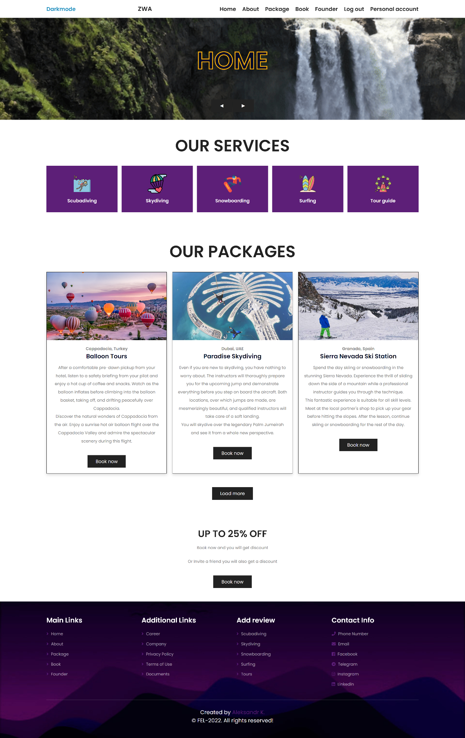

/*

** Description of the website

*/

/*

---------------------------------------------------------------------------------------------

Main Links

---------------------------------------------------------------------------------------------

*/

/*

** Home page

*/

Home page on the website.

In the Header section, there is a navigation menu in which the main pages are visible. Also in the Header section, you can put the dark theme of Darkmode.

Registered users can access their profile page.

If the user is not registered, then he can register. But there is a mandatory rule when registering, you cannot use the same login and email. If the user is already logged in, then he can log out of his account.

On the Home page, you can navigate to the next page using the arrow buttons.

There is also a section for our services, travel packages, and a discounted advertisement if you book our services now.

At the bottom of the site is the Footer section, where columns with main and additional links are located.

Main links have sections: Home, About, Package, Booking and Founder.

Additional links have sections: Career, Company, Privacy, Terms of Use.

Also in the Footer section, there is the contact information for contacting the site owner, namely: Phone Number, Email, Facebook, Telegram, Instagram, and LinkedIn.

/*

** About page

*/

On this page there will be some information about the company Travel. On the About page, you can select a section with comments.

On the About page, you can navigate to the next page using the arrow buttons.

/*

** Packages page

*/

On this page you can look at all travel packages, each of which contains a detailed description and a picture. If the client is interested in any travel package, it is possible to book it.

On the Packages page, you can navigate to the next page using the arrow buttons.

/*

** Booking page

*/

Page for booking any tour or travel package.

On this page, the client can leave a request for booking.

The client fills out a special form, fills in personal data, where he wants to go, the date of the trip. The completed form is sent to our database, after which a special worker contacts the client.

On the Booking page, you can navigate to the next page using the arrow buttons.

/*

** Founder page

*/

This page contains information about the creator of Travel Countries and the creator of this website. Here are the phone number and email address.

On the Founder page, you can navigate to the next page using the arrow buttons.

/*

** Register page

*/

This page was created to register new users.

/*

** Login page

*/

This page was created for registered users to enter their personal page.

/*

** Logout page (Available only for authorized users)

*/

Logging out means ending access to the website.

/*

** Personal account page (Available only for authorized users)

*/

The personal page of the user who logged in.

/*

---------------------------------------------------------------------------------------------

Service

---------------------------------------------------------------------------------------------

*/

/*

** Scuba diving page

*/

Page with tour packages with the topic Scuba diving. Users view, leave, and read comments.

/*

** Skydiving page

*/

Page with tour packages with the topic Skydiving. Users view, leave, and read comments.

/*

** Snowboarding page

*/

Page with tour packages with the topic Snowboarding. Users view, leave, and read comments.

/*

** Surfing page

*/

Page with tour packages with the topic Surfing. Users view, leave, and read comments.

/*

** Tour page

*/

Page with tour packages with the topic Tour. Users view, leave, and read comments.

/*

---------------------------------------------------------------------------------------------

Additional Links

---------------------------------------------------------------------------------------------

*/

/*

** Career page

*/

This page lists vacancies, namely programmers are required.

/*

** Company page

*/

This page contains contact details of partners from other countries.

On this page, pagination is implemented (in the Czech version, strankovani). The data displayed on this page has been imported from the Database.

/*

** Documents page

*/

This page contains documentation for the semester project.

/*

** Privacy Policy page

*/

This page explains how an organization handles any customer or employee information collected during its operations.

/*

** Terms of Use page

*/

Terms of Use are legal agreements between a service provider and a person who wants to use the service.